

**Project report for**

**FITNESS TRACKing system**



**GROUP – 9 , CSE “L” SECTION**

Srikar Pepeti   
 AP21110010741

Sri Sai Varun Vadlakonda   
 AP21110010742

Table of Contents

1.ABSTRACT 3

2.PROBLEM DEFINITION 4

3.PROPOSED SYSTEM 4

4.SYSTEM REQUIREMENTS 4

5.ALGORITHM 5

6.FLOWCHART 7

7

8

7. COMPLETE CODE 9

8. SCREENSHOTS 15

9. REFRENCES 19

# 1.ABSTRACT

The main purpose of this Fitness Tracker is to help you reach your fitness goals and lead a Healthy Life.

This Fitness Tracker is a software program which enables the user to track their body mass index(BMI), current fitness level, calories to be consumed in a day, Types of Activities, Diet and Nutrition etc.

# 2.PROBLEM DEFINITION

Topic : Health, Fitness.

Due to the modern sedentary lifestyle health issues are on the rise.

The convenience of Food delivery system made all the the Junk Food easily available at our doorstep, those processed foods which are high in simple carbohydrates and fats results more Fat Accumulation in the Body.

Hence making People Unfit

# 3.PROPOSED SYSTEM

The Proposed system helps us to :

1) Calculate Body Mass Index(BMI)

2) Calculate your present Maintenance Calories?

3) Calculate calories of different foods

4) Follow Diet and Nutrition

5) Know which Physical activity can be Done?

# 4.SYSTEM REQUIREMENTS

A System Requirements Specification (SRS) (also known as a Software Requirements Specification) is a document or set of documentation that describes the features and behavior of a system or software application.

**4.1 SOFTWARE REQUIREMENTS**

The software requirements are description of features and functionalities of the target system.

1. Operating System: Windows
2. GCC

**4.2 HARDWARE REQUIREMENTS**

Hardware requirements often specify the operating system version, processor type, memory size, available disk space and additional peripherals.

1.Processor: x86 based system.

2.Keyboard

3. Mouse

4. Monitor

# 5.ALGORITHM

Step 1 : First when we run the program it will ask our name.

Step 2 : Then the Main Menu will be appeared and it consists of 7 options

Step 3 : It reads the input from the user

* Introduction

Step 4 : It displays the basic information about the program and explains how to use it

* Calculating BMI

Step 5 : It reads the input(height and weight) from the user

Step 6 : Displays the BMI and tells about the current body situation of the user

* Maintenance Calories

Step 7 : It shows the weight in ponds and displays the Current Maintenance calories of the user

Step 8 : Then according to the BMI, It displays the present maintenance calories to be consumed in order to reach the goal of the user

* Calorie Calculation

Step 9 : It tells the user how to calculate the calories present in different Food items

* Diet and Nutrition

Step 10 : It gives an idea to the user about what all should be included in the daily diet for better results

* Physical Activities

Step 11 : It tells the user what all physical activities can be performed

Step 12 : End of Program

* Exit Program

# 6.FLOWCHART

# 

# 

# 7. COMPLETE CODE

#include<stdio.h>

//Function Declarations

float BMI (float,float);

int MC (float);

void read_file(char * file);

//Global Variables

float wt, ht, bmi;

//Main Function

int main()

{

  //Part 1

  printf("********** Welcome to Fitness Tracking System **********\n\n");

  printf("Enter your name : ");

  char name[50];

  scanf("%s", name);

  printf("\nHello %s \n\n", name);

  //Part 2

  int num;

  float wt, ht, bmi, mc;

  do{

  printf("\t********** MENU **********\n\n");

  printf("1) What is this Fitness Tracking System and how to use it?\n");

  printf("2) To Calculate Body Mass Index(BMI)\n");

  printf("3) How to calculate your present Maintenance Calories?\n");

  printf("4) How to calculate calories of different foods\n");

  printf("5) How to follow Diet and Nutrition\n");

  printf("6) Which Physical activity can be Done?\n");

  printf("7) Exit Program\n\n");

  printf("Enter the respective number according to your choice : ");

  scanf("%d", &num);

  switch(num)

  {

      case 1 : printf("1) \n");

               read_file("intro.txt");

               break;

      case 2 : printf("2) ");

               bmi = BMI (wt,ht);

               break;

      case 3 : printf("3) ");

               mc = MC (wt);

               break;

      case 4 : printf("4)");

               FILE *fp2;

               fp2=fopen("ccal" , "r");

               int ch;

               while((ch = fgetc(fp2))!=EOF)

               {

                 printf("%c", ch);

               }

               fclose(fp2);

               break;

      case 5 : printf("5) ");

               FILE *fp3;

               fp3=fopen("diet" , "r");

               int ch2;

               while((ch2 = fgetc(fp3))!=EOF)

               {

                 printf("%c", ch2);

               }

               fclose(fp3);

               break;

      case 6 : printf("6) ");

               FILE *fp4;

               fp4=fopen("exercise" , "r");

               int ch3;

               while((ch3 = fgetc(fp4))!=EOF)

               {

                 printf("%c", ch3);

               }

               fclose(fp4);

               break;

     case 7 : printf("\n***** End of Program *****\n\n");

              break;

    default : printf("invalid choice, Enter a Valid number\n\n\n");

  }

  }

  while(num!=7);

    return 0;

}

//BMI Function

float BMI (float wt, float ht)

{

  float bmi;

  printf("\nEnter your weight in kg and height in meters\n");

  scanf("%f %f", &wt,&ht);

  bmi= wt / (ht*ht);

  if (bmi < 18.5)

      {

          printf("You are under weight\n\n");

      }

  else if (bmi > 18.5 && bmi < 24.9)

      {

           printf("Your Physique is Absolutely perfect\n\n");

      }

  else if (bmi > 25.0 && bmi < 29.9)

       {

           printf("You are OverWeight\n\n");

       }

  else if (bmi > 30.0 && bmi < 34.9)

       {

           printf("You are obese\n\n");

       }

  else if (bmi > 35.0 && bmi < 39.9)

       {

           printf("You are Heavily obese\n\n");

       }

  else

       {

           printf("You have severe morbid obesity\n\n");

       }

  }

  //Maintenance Calorie Calculator Function

  int MC (float wt)

  {

      int mc;

      printf("Enter your weight in kg and height in meters : ");

      scanf("%f%f", &wt, &ht);

      bmi= wt / (ht*ht);

      printf("Your weight in kg is %f\n", wt);

      wt = wt * 2.20462;    //converting kg to pounds

      printf("Your weight in pounds is %f\n", wt);

      mc = wt * 15;      //Calculating maintenance calories

      printf("Your present Maintenance Calories are %d\n", mc);

      printf("These are the calories that you should consume in a day\n");

      printf("Your current BMI is %f , So\n", bmi);

      if (bmi < 18.5)

      {

          printf("You should Gain Weight in order to stay healthy\n");

          mc = mc + 200;

          printf("To gain weight you should eat more than your maintenance calories\n");

          printf("So your Total calories to be consumed in a day are %d\n\n\n", mc);

      }

      else if (bmi > 18.5 && bmi < 25)

      {

          printf("You should Maintain your weight in order to stay healthy\n");

          printf("To Maintain your weight you should eat the same amount as your maintenance calories\n");

          printf("So your Total calories to be consumed in a day are %d\n\n\n", mc);

      }

      else

      {

          printf("You should Loose weight in order to stay healthy\n");

          mc = mc - 200;

          printf("To Loose weight you should eat less than your maintenance calories\n");

          printf("So your Total calories to be consumed in a day are %d\n\n\n", mc);

      }

      return mc;

  }

  //Introduction File Function 1

  void read_file(char * file)

  {

     FILE *fp1;

     fp1 = fopen("intro" , "r");

     int ch;

     while((ch=fgetc(fp1))!=EOF)

     {

        printf("%c", ch);

     }

     fclose(fp1);

  }

# 8. SCREENSHOTS

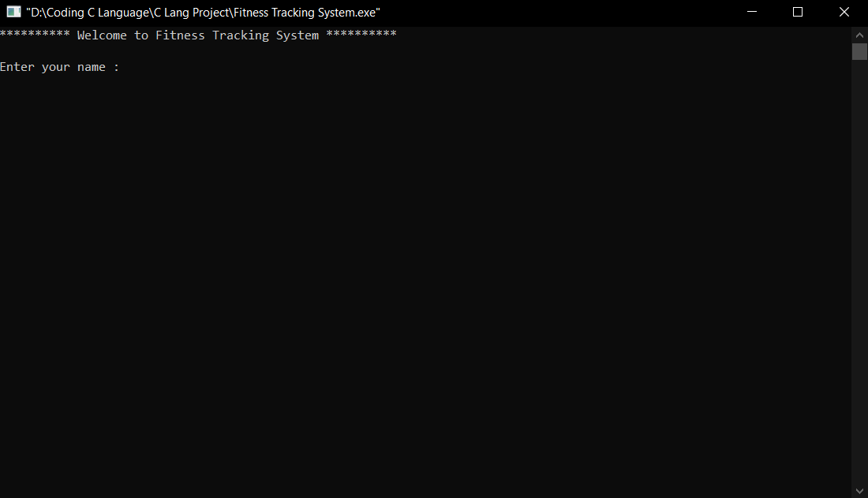

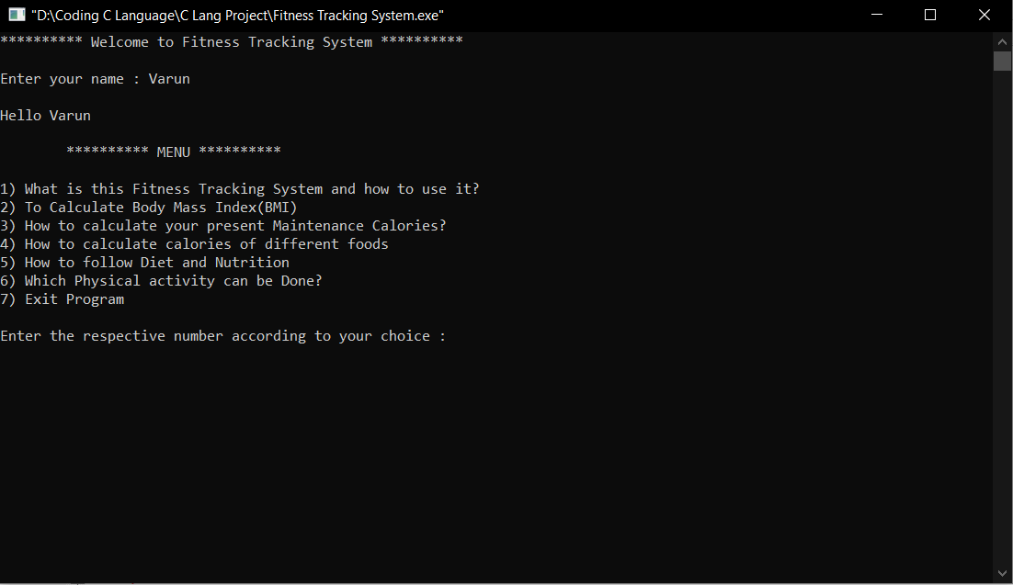

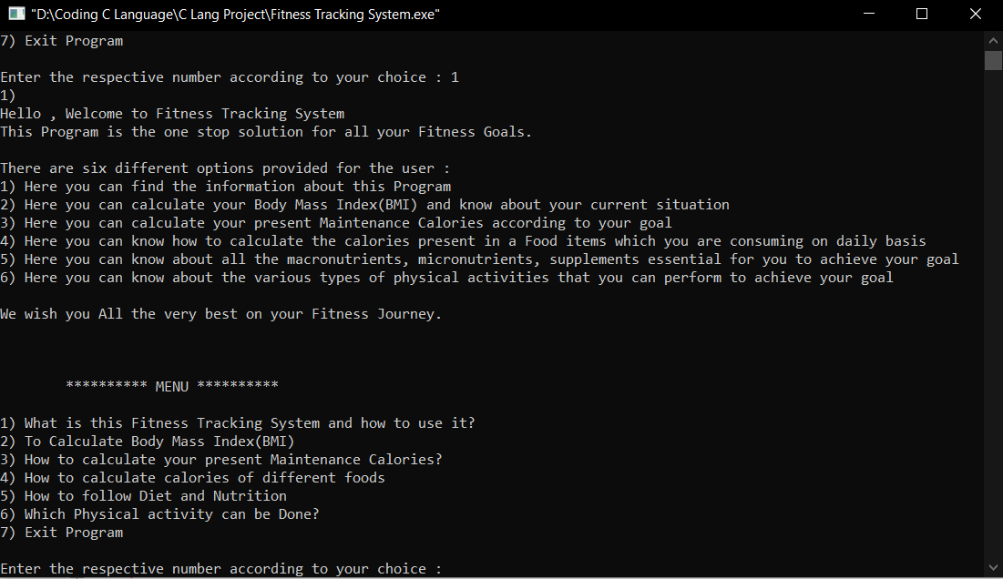

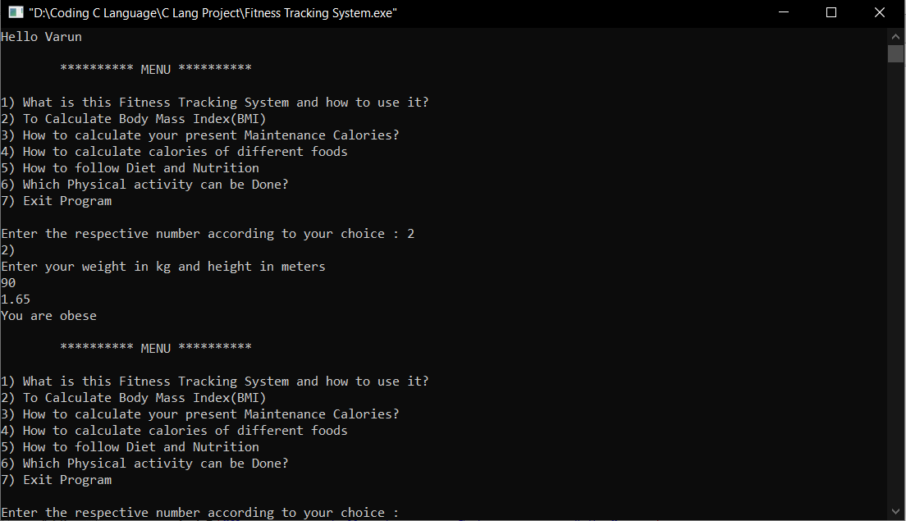

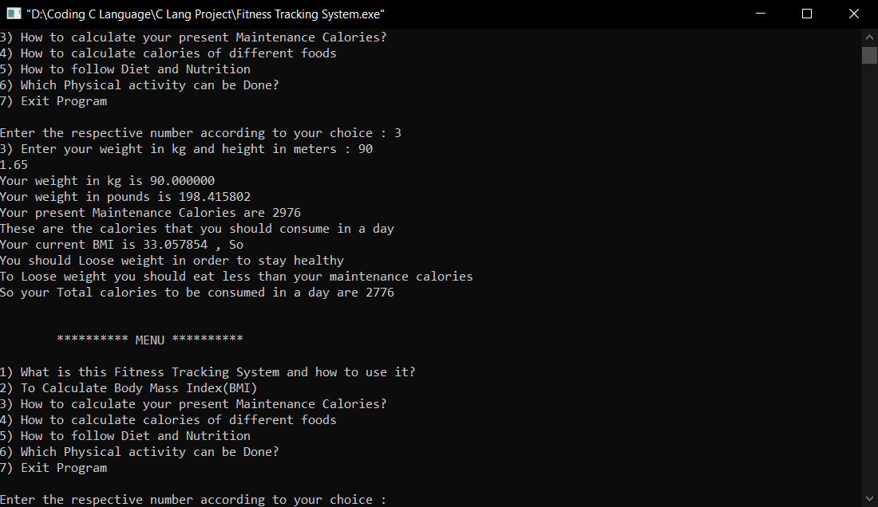

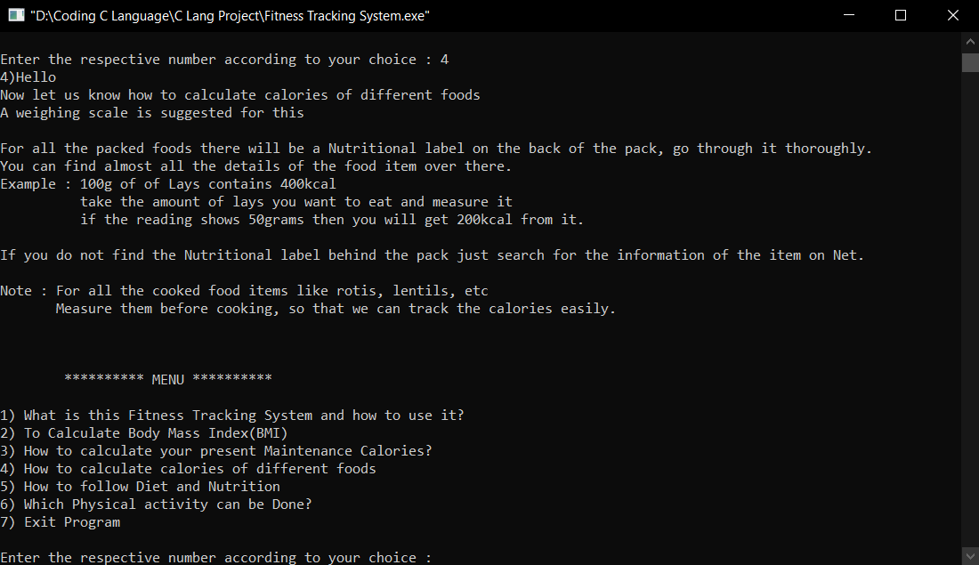

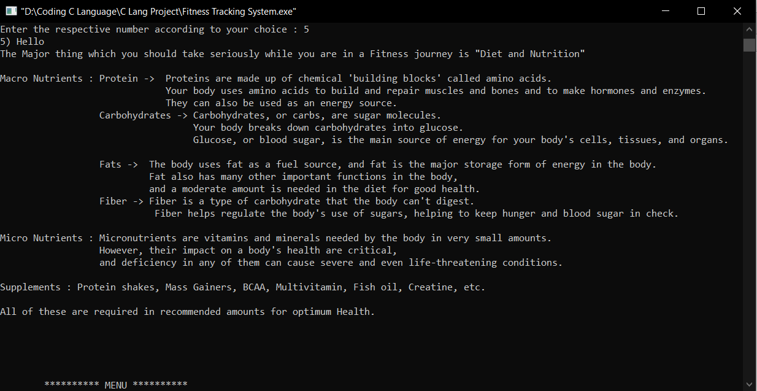

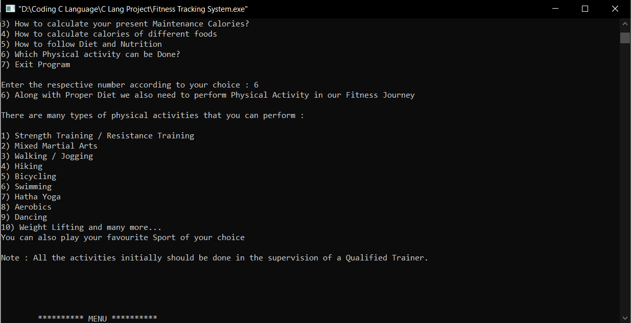

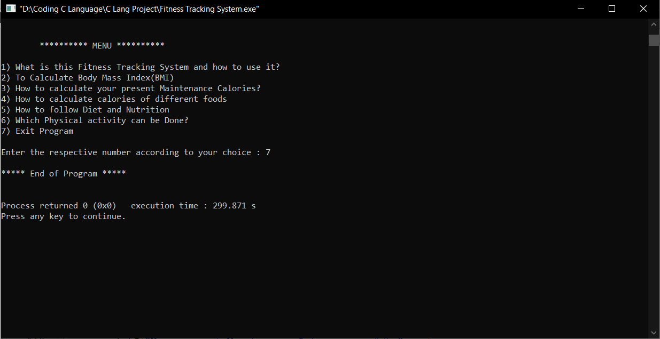

# 9. REFRENCES

<https://www.youtube.com/watch?v=aUqO-dgzMw4&list=PLLOxZwkBK52AE9jFVOGZTJxaiAC_xB8Yy&ab_channel=SundeepSaradhiKanthety>

<https://www.youtube.com/watch?v=si-KFFOW2gw&list=PLVlQHNRLflP8IGz6OXwlV_lgHgc72aXlh&ab_channel=NareshiTechnologies>

<https://www.youtube.com/watch?v=ZSPZob_1TOk&t=15705s&ab_channel=CodeWithHarry>